
Touchstones Project
Netcards

Awe Netcards with Text

Astonished HRJ
Beautiful or Difficult HRJ
Black Lives Matter HRJ
Celestial Torches HRJ

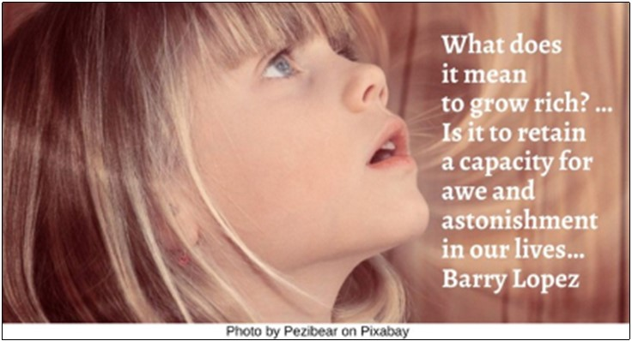





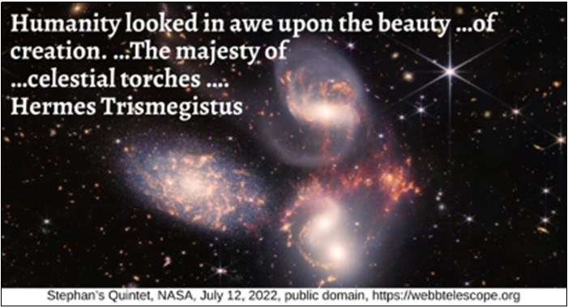

Chimpanzee HRJ
Church HRJ
Cracks HRJ
Desert HRJ

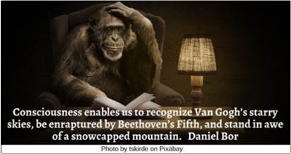

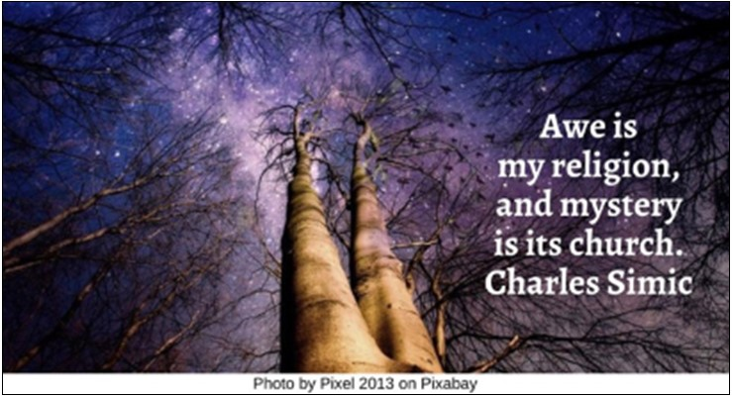

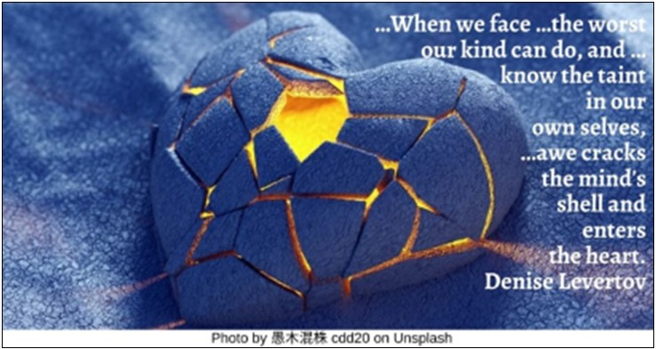

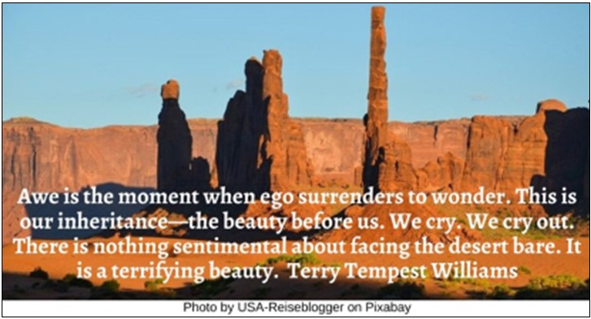

Emily Dickinson HRJ
Fish HRJ
Flower HRJ
Grandeur HRJ

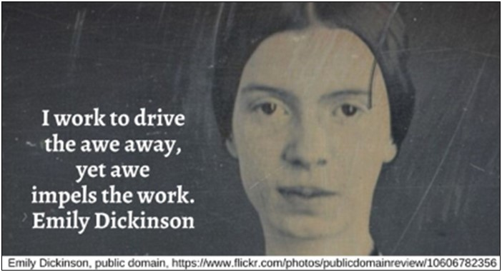

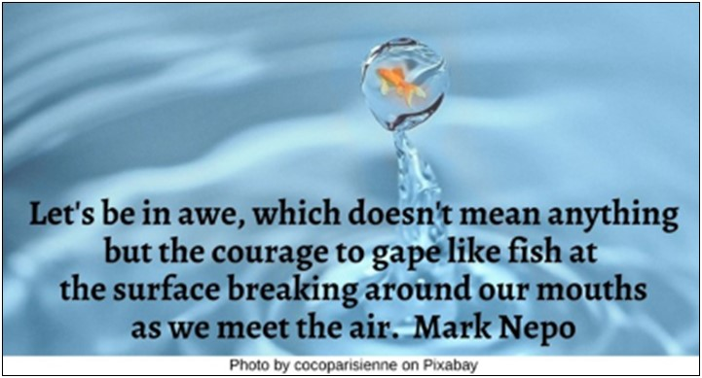

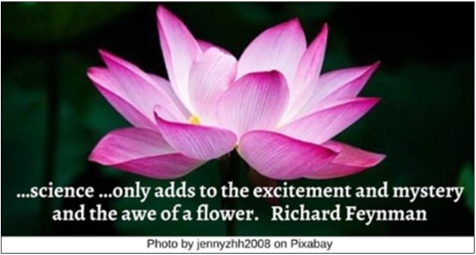

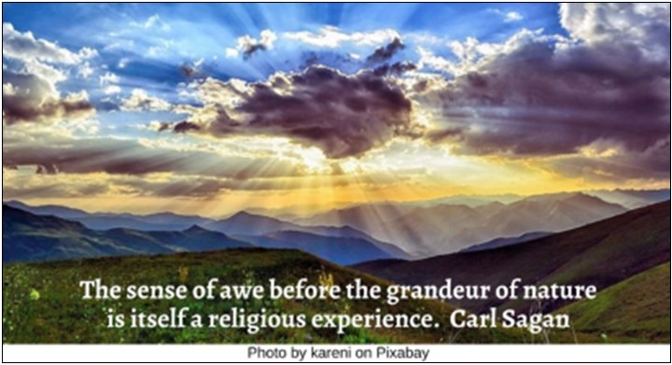

Holy Curiosity HRJ
Hurt HRJ
Imagination HRJ
In Awe HRJ

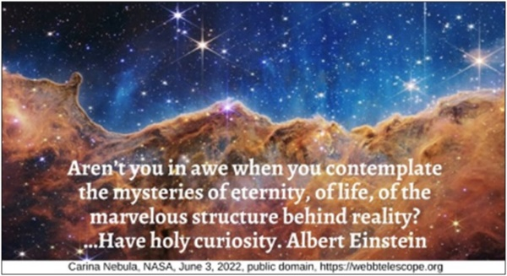



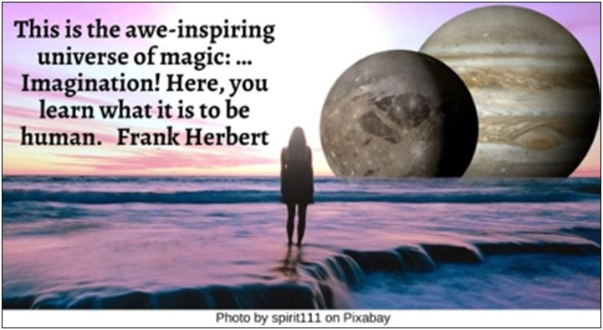

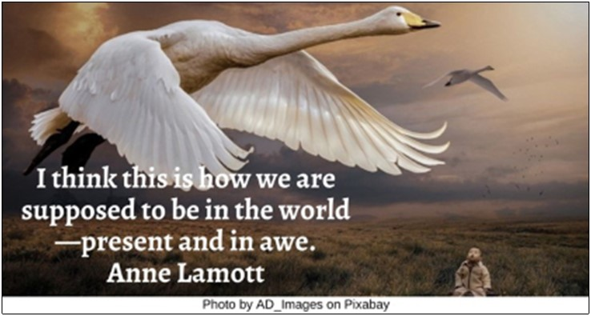

Marilyn Monroe HRJ
Mole HRJ
Mystery HRJ
Ocean Sunset HRJ



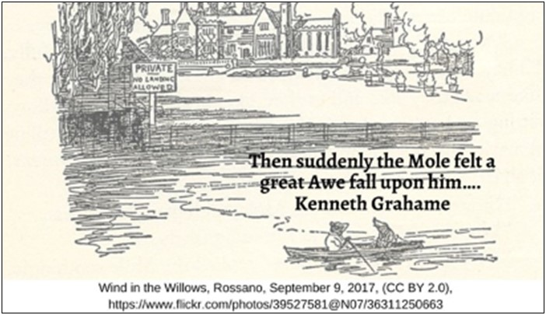

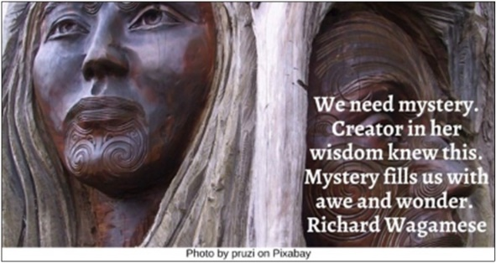

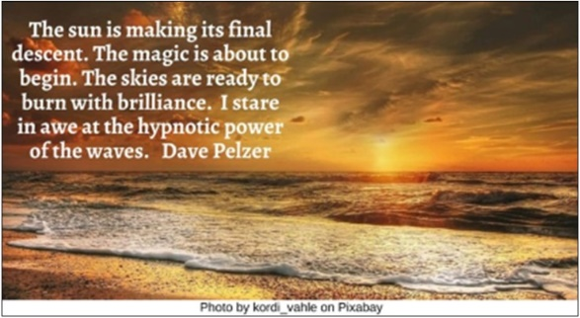

Old Man HRJ
Orange Purple Sky HRJ
Orion HRJ
Redwood Tree HRJ



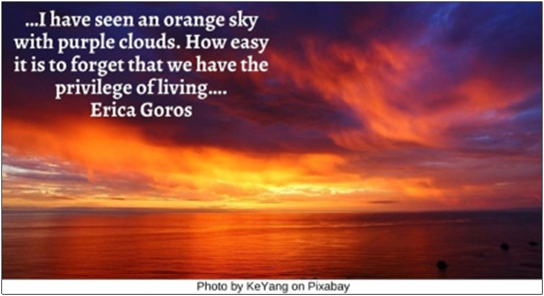

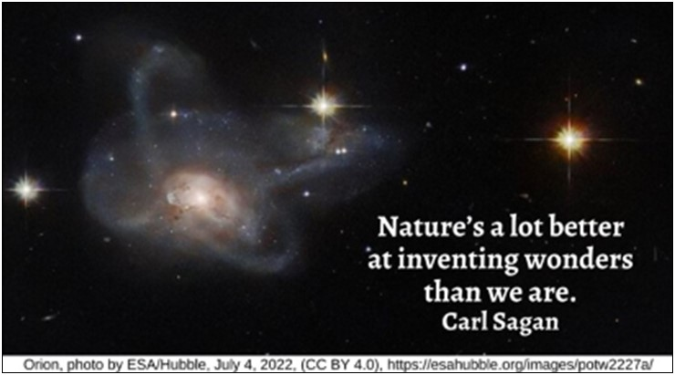

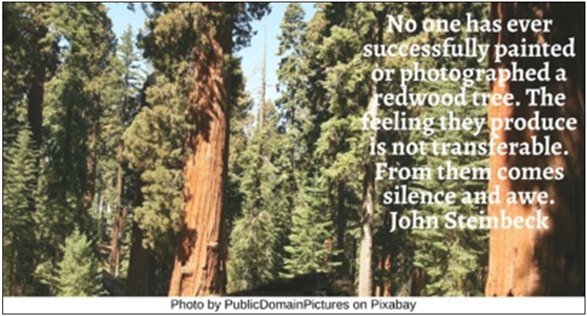

Sacred Awe HRJ
Silence HRJ
Snow HRJ
Splintered Wreck HRJ

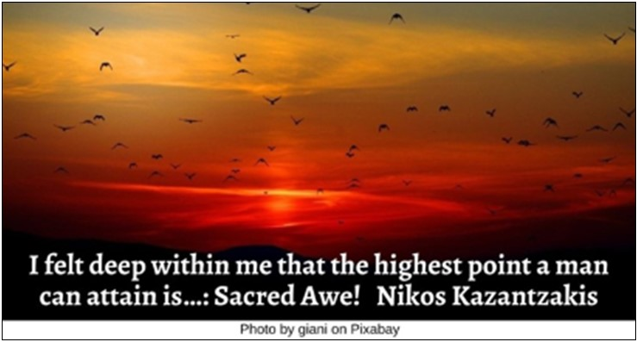

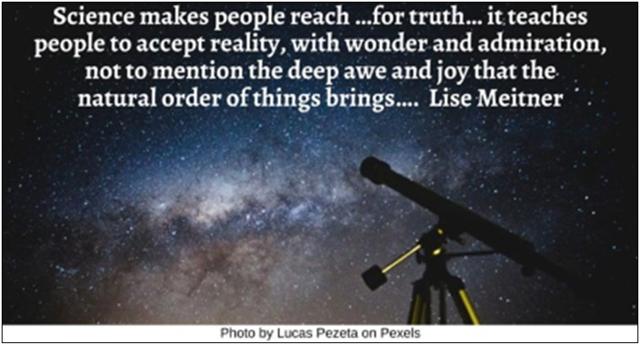

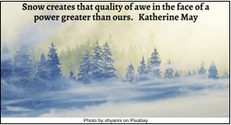

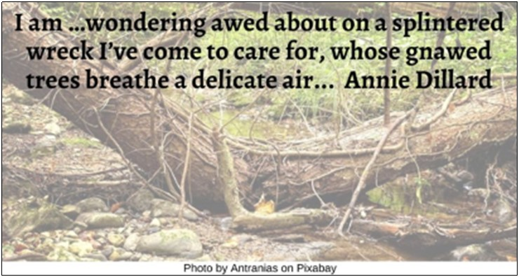

Thirst HRJ
Understanding HRJ
Yellowstone River HRJ

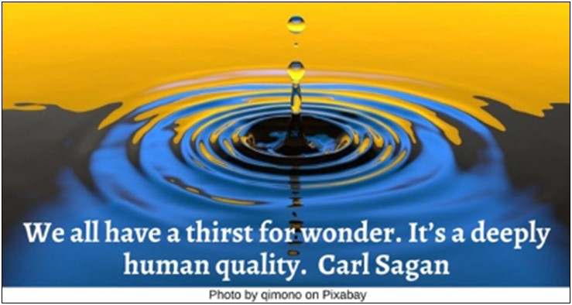



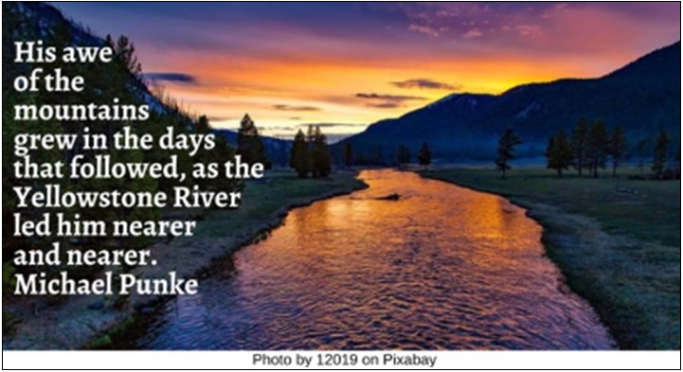

Text of Quotes
Astonished HRJ
What does it mean to grow rich? …Is it to retain a capacity for awe and astonishment in our lives… Barry Lopez

Beautiful or Difficult HRJ
I am in awe of the beautiful moments life gives us, and I am in awe of the difficult ones. Bianca Sparacino

Black Lives Matter HRJ
It made me love talk that sought answers …that could help nobody, that could only keep alive in me …wonder and awe…. Richard Wright, author, Black Boy

Celestial Torches HRJ
Humanity looked in awe upon the beauty …of creation. …The majesty of …celestial torches …. Hermes Trismegistus

Chimpanzee HRJ
Consciousness enables us to recognize Van Gogh’s starry skies, be enraptured by Beethoven’s Fifth, and stand in awe of a snowcapped mountain. Daniel Bor

Church HRJ
Awe is my religion, and mystery is its church. Charles Simic

Cracks HRJ
…When we face …the worst our kind can do, and …know the taint in our own selves, …awe cracks the mind's shell and enters the heart. Denise Levertov

Desert HRJ
Awe is the moment when ego surrenders to wonder. This is our inheritance—the beauty before us. We cry. We cry out. There is nothing sentimental about facing the desert bare. It is a terrifying beauty. Terry Tempest Williams

Emily Dickinson HRJ
I work to drive the awe away, yet awe impels the work. Emily Dickinson

Fish HRJ
Let's be in awe, which doesn't mean anything but the courage to gape like fish at the surface breaking around our mouths as we meet the air. Mark Nepo

Flower HRJ
…science …only adds to the excitement and mystery and the awe of a flower. Richard Feynman

Grandeur HRJ
The sense of awe before the grandeur of nature is itself a religious experience. Carl Sagan

Holy Curiosity HRJ
Aren’t you in awe when you contemplate the mysteries of eternity, of life, of the marvelous structure behind reality? …Have holy curiosity. Albert Einstein

Hurt HRJ
Sometimes, it’s the people who have been hurt the most who refuse to be hardened…. If that isn’t something to be in awe of, I don’t know what is. Bianca Sparacino

Imagination HRJ
This is the awe-inspiring universe of magic: …Imagination! Here, you learn what it is to be human. Frank Herbert

In Awe HRJ
I think this is how we are supposed to be in the world—present and in awe. Anne Lamott

Marilyn Monroe HRJ
I am in awe of the things you've been put through and the fact you can still light up a room when you walk in. Abbi Glines
Mole HRJ
Then suddenly the Mole felt a great Awe fall upon him…. Kenneth Grahame

Mystery HRJ
We need mystery. Creator in her wisdom knew this. Mystery fills us with awe and wonder. Richard Wagamese

Ocean Sunset HRJ
The sun is making its final descent. The magic is about to begin. The skies are ready to burn with brilliance. I stare in awe at the hypnotic power of the waves. Dave Pelzer

Old Man HRJ
Nothing inspires more reverence and awe in me than an old man who knows how to change his mind. Santiago Ramón Y Cajal

Orange Purple Sky HRJ
…I have seen an orange sky with purple clouds. How easy it is to forget that we have the privilege of living…. Erica Goros

Orion HRJ
Nature’s a lot better at inventing wonders than we are. Carl Sagan

Redwood Tree HRJ
No one has ever successfully painted or photographed a redwood tree. The feeling they produce is not transferable. From them comes silence and awe. John Steinbeck

Sacred Awe HRJ
I felt deep within me that the highest point a man can attain is…: Sacred Awe! Nikos Kazantzakis

Science HRJ
Science makes people reach …for truth… it teaches people to accept reality, with wonder and admiration, not to mention the deep awe and joy that the natural order of things brings…. Lise Meitner
Snow HRJ
Snow creates that quality of awe in the face of a power greater than ours. Katherine May

Splintered Wreck HRJ
I am …wondering awed about on a splintered wreck I’ve come to care for, whose gnawed trees breathe a delicate air... Annie Dillard

Thirst HRJ
We all have a thirst f
or wonder. It’s a deeply human quality. Carl Sagan

Understanding HRJ
I’d take the awe of understanding over the awe of ignorance any day. Douglas Adams

Yellowstone River HRJ
His awe of the mountains grew in the days that followed, as the Yellowstone River led him nearer and nearer. Michael Punke

